PLANNING & ACCESS COMMITTEE

PARTICIPATION FORM

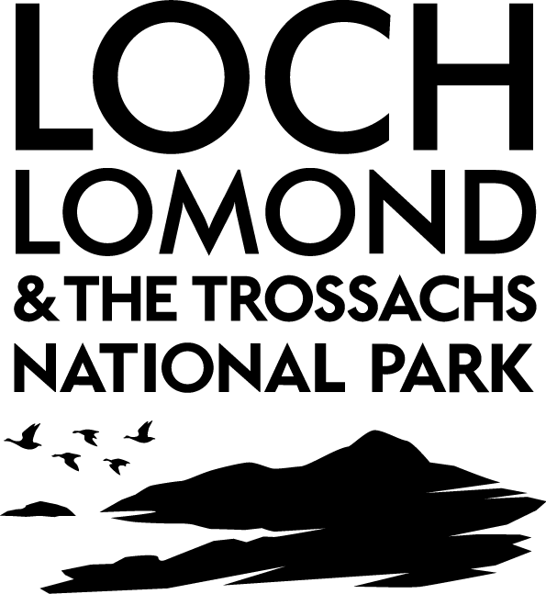
NOTE: You may only complete this form if you have already made a written representation to the National Park Authority on the relevant application.
Please refer to the guidance leaflet prior to completing this form.

APPLICATION DETAILS
Date of meeting:
Planning Application No.

DETAILS OF SPEAKER
Name of speaker:
Address:

Daytime contact number:
e-mail address:
PLEASE TICK THE APPROPRIATE BOX:
1. | I wish to speak: in objection to the proposal  in support of the proposal
2. | At the meeting I wish to represent: myself  Another person / organisation
3. | If representing another person or an organisation, please give details below  ____________________________________________________________  Please tick here to confirm that you have authorisation to represent the above party
PLEASE PROVIDE A SUMMARY OF YOUR REPRESENTATION Note: Only relevant planning matters can be raised - please see overleaf for guidance

Please complete all sections of Page 1 and return this form to: Nicola Arnott, Committee Clerk, Loch Lomond & The Trossachs National Park, Carrochan, 20 Carrochan Road, Balloch, G83 8EG. Tel: 01389 722600, Fax: 01389 722633 or e-mail committeeclerk@lochlomond-trossachs.org

Note: This form must be received by the Committee Clerk leaving 2.5 clear working days before the designated Committee meeting (for example, if the meeting is on a Monday, requests must be received by 12 noon on the previous Wednesday).
Any late requests will not be considered.

GUIDANCE ON RELEVANT PLANNING MATTERS
Note: The following examples are given for guidance, however, the lists are not exhaustive
Relevant | Not Relevant
- Structure and Local Plan Policies;  - Government planning guidance;  - Planning law and previous decisions;  - Highway safety and traffic;  - Impact on residential amenity;  - Design appearance and layout;  - Impact on trees, listed buildings, conservation areas and landscape;  - Relationship with existing buildings and uses; or  - Noise, disturbance and smells. | - Boundary or area disputes;  - Suspected future development;  - The applicant’s perceived motives;  - Loss of view; or  - Effect on value of property.

Data Protection Act 1998, Freedom of Information (Scotland) Act 2002 and

Environmental (Scotland) Regulations 2004

This Public Participation Form is only for the use of the NPA to enable them to schedule a time to allow you to make representations
at the designated Planning Committee meeting. A copy of your participation form will be provided to our Planning Committee Members in advance of the designated Planning Committee meeting. Please note that your name will be disclosed at the designated Planning Committee meeting, but your other personal details (address, telephone number and email address) will only be used if the NPA need to contact you to discuss your representation or to clarify any information which you have added to the form. A copy of your participation form will be held by the NPA for a period of one year, after which it will be destroyed securely.

As the NPA is subject to the provisions of the Freedom of Information (Scotland) Act 2002 and the Environmental Information (Scotland) Regulations 2004, your completed Public Participation Form may be the subject, or fall within the scope, of a request made under the aforementioned legislation.

Please tick this box if you do not wish your personal details to be disclosed in the event that such a request is received . In any event, the NPA will only release personal data where there is a justification for doing so, and in accordance with the Data Protection Act 1998.

For completion by National Park Authority

Form received:

Date confirmed:

Confirmed by:

