|  |
| --- |
|  |

**Guess how many nuts Cormie has in his jar**

**1st Prize – HP Stream 7” Tablet PC with Windows 8.1 (free Windows 10 upgrade) and Office 365 (Word, Excel etc.).**

|  |
| --- |
|  |

**2nd Prize – Cormie, Nuts and Jar**

**Only £1 or Free when you join CWA Today!!!**

My name’s **Cormie** and I’m a red squirrel from Argyll. I’m named after the Cormonachan Woodlands on the banks of Loch Goil where I live with lots of my squirrel friends.

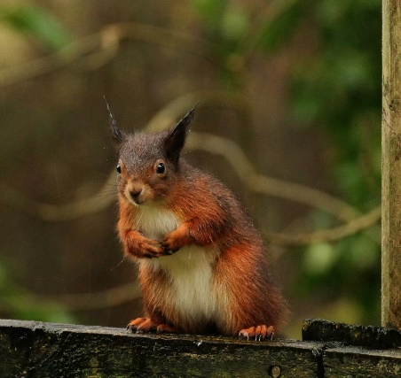Our wood is called an ‘Atlantic Oak Forest’, but although there are lots of oak trees, we also have many other sorts of tree such as hazel and scots pine. I’m told I live in “The rain forest of the North” – well it certainly rains a lot so that must be true.

Here in Argyll and in most of the Highlands of Scotland the squirrels are small and red like me and there’s lots of us about. If you go walking around Loch Goil you will probably see a few of us as we stay out in the daylight and aren’t very shy of humans. In fact if you put out a bird feeder with some nuts and seeds you will have difficulty keeping me and my friends away. I’m proud to say that no human has ever invented a truly squirrel-proof nut container, and I am pretty determined to keep it that way.

I’ve heard that down south and in the cities there is another sort of squirrel which is bigger than me and grey. It doesn’t really come from here, it eats my food and also can give me a disease which kills me. So here in the Highlands everyone has to watch out for them. Luckily humans are doing much more to protect me and make sure I have secure places like the Cormonachan Woodlands to live in.

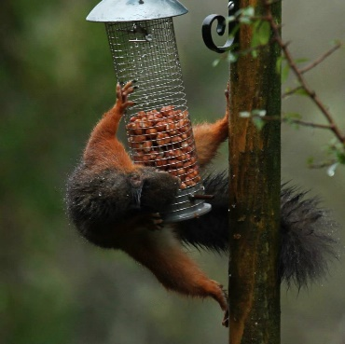Lots of other creatures share my home in the woods. There are lots of deer, so many in fact that the humans have to make fences to keep them out. We have some badgers, but not too many because our weather is a bit soggy for them as they live underground, foxes, otters which live in the Loch and wash the salt off their fur in rivers like the Donich and the Cormonachan burn. One sort of animal we have in our woods that I am not very fond of is pine martens. They try very hard to eat us and climb trees to do it, but don’t often succeed because we are too fast for them. As well as this we have seals, porpoises and whales in the loch, lots of different sorts of birds (I’m scared of eagles but I don’t mind the rest too much) and some rare plants. We even have a special sort of lichen which people come here to study.

Anyway, I hope you enjoy your time at our Gala. **Don’t forget to try to guess how many nuts I have in my jar and you could win a tablet PC….**  Oh and if you live here or if you are staying on holiday – don’t forget to put some food out for me and my friends – we appreciate it far more than the birds do.

**Cormie** the Red Squirrel

|  |
| --- |
| Sponsored by ScotSTS Ltd - Web Security made in Scotland |