fdfdsfsdfsdfsd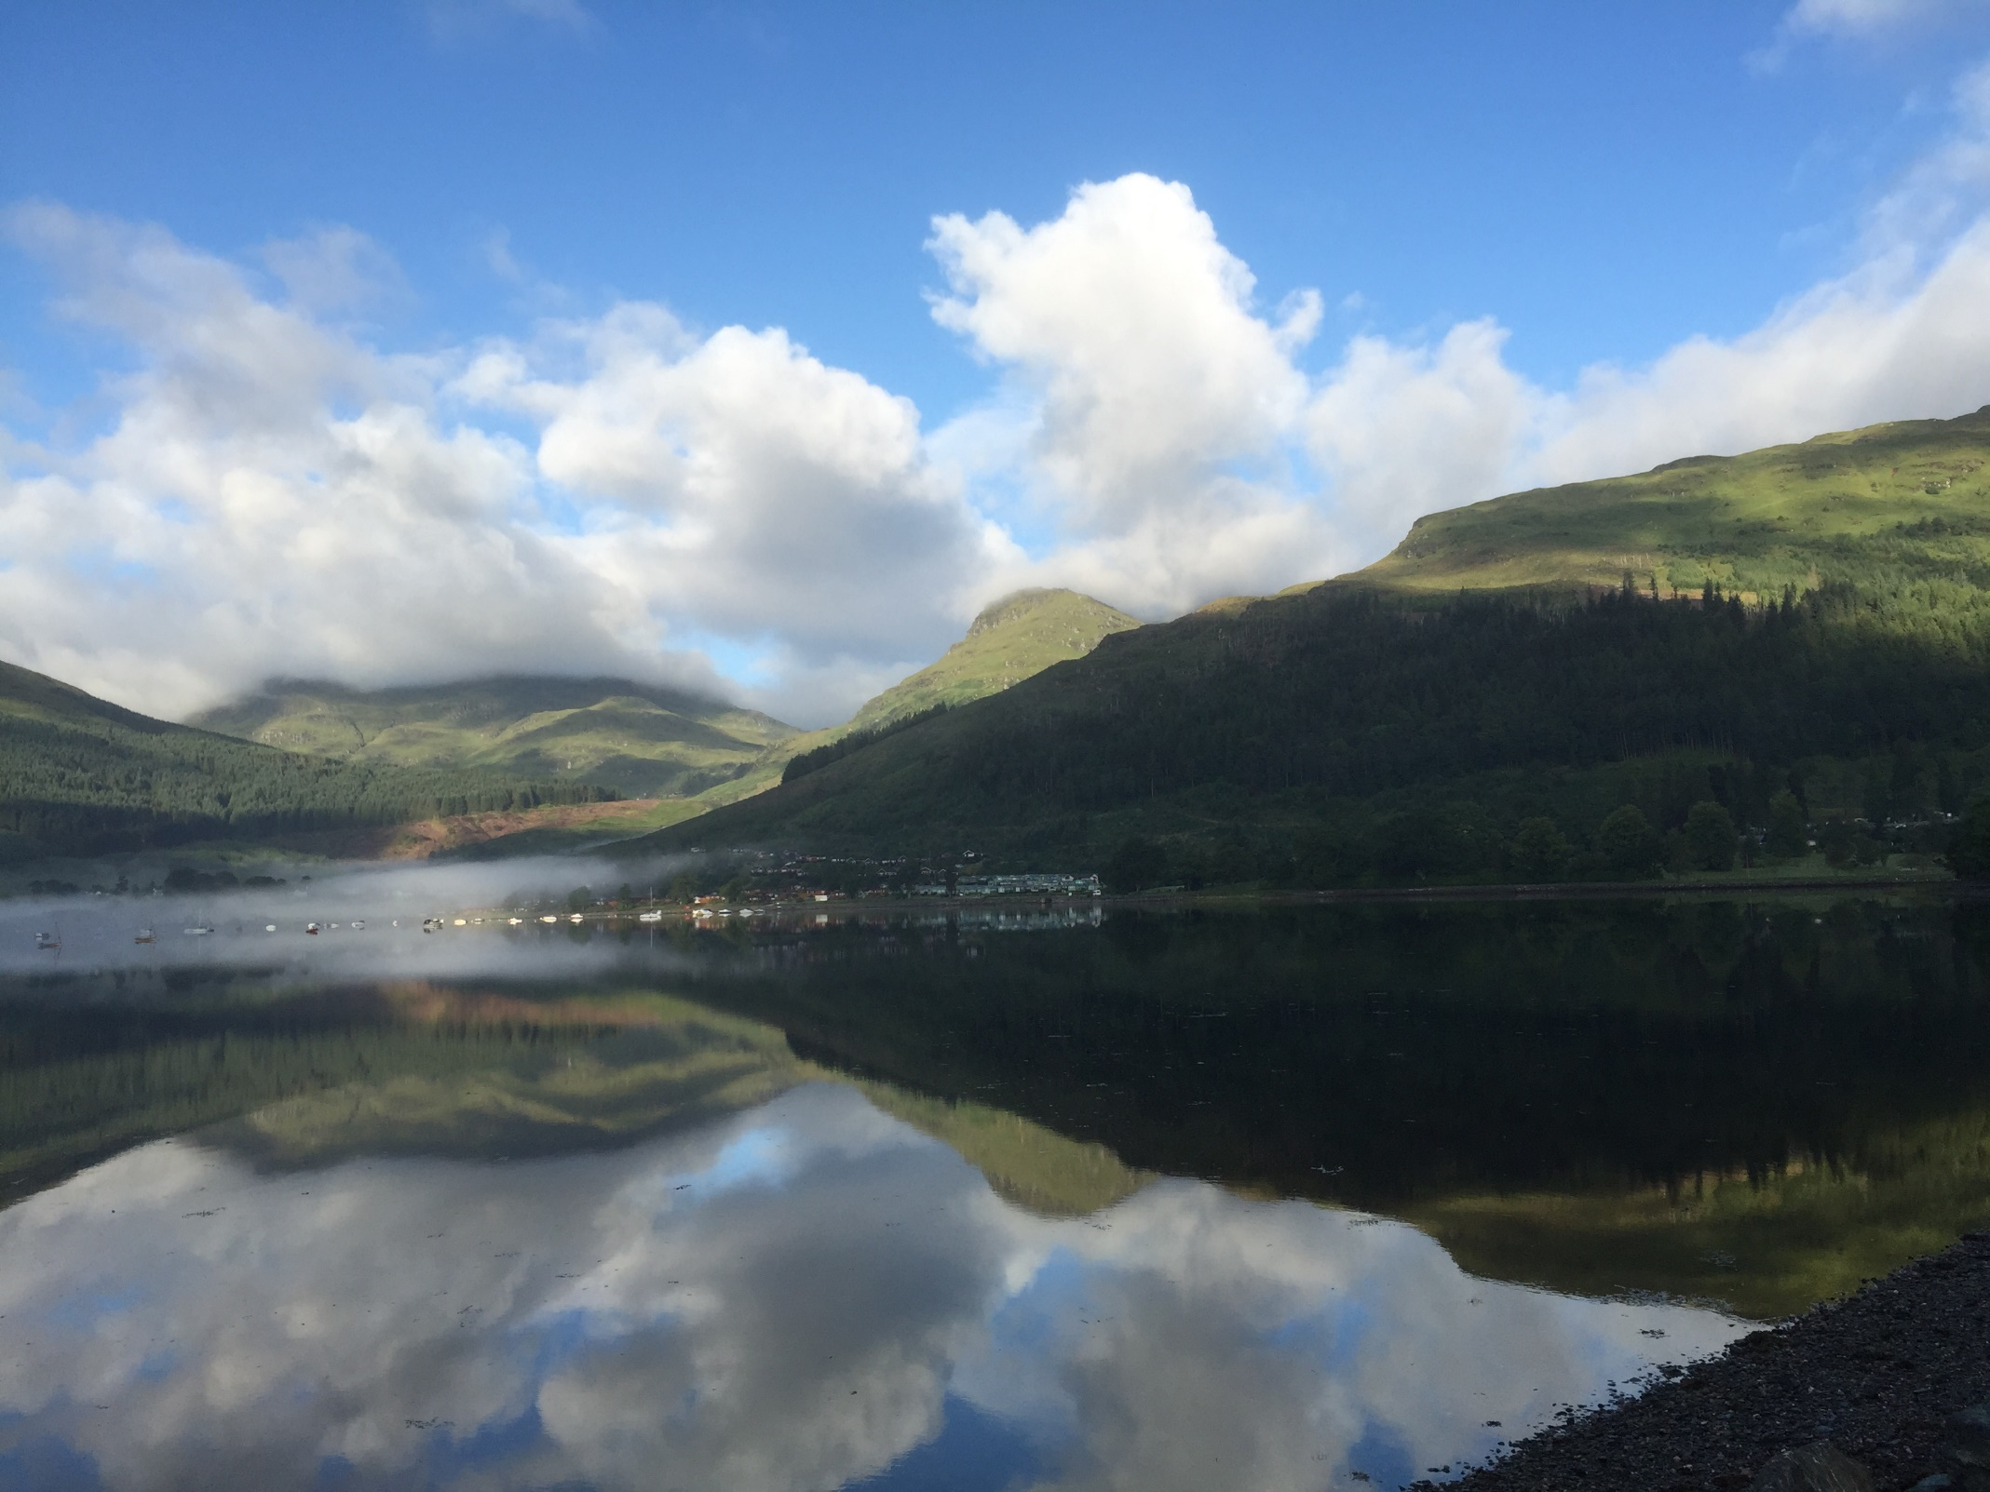
Loch Goil Calendar 2016

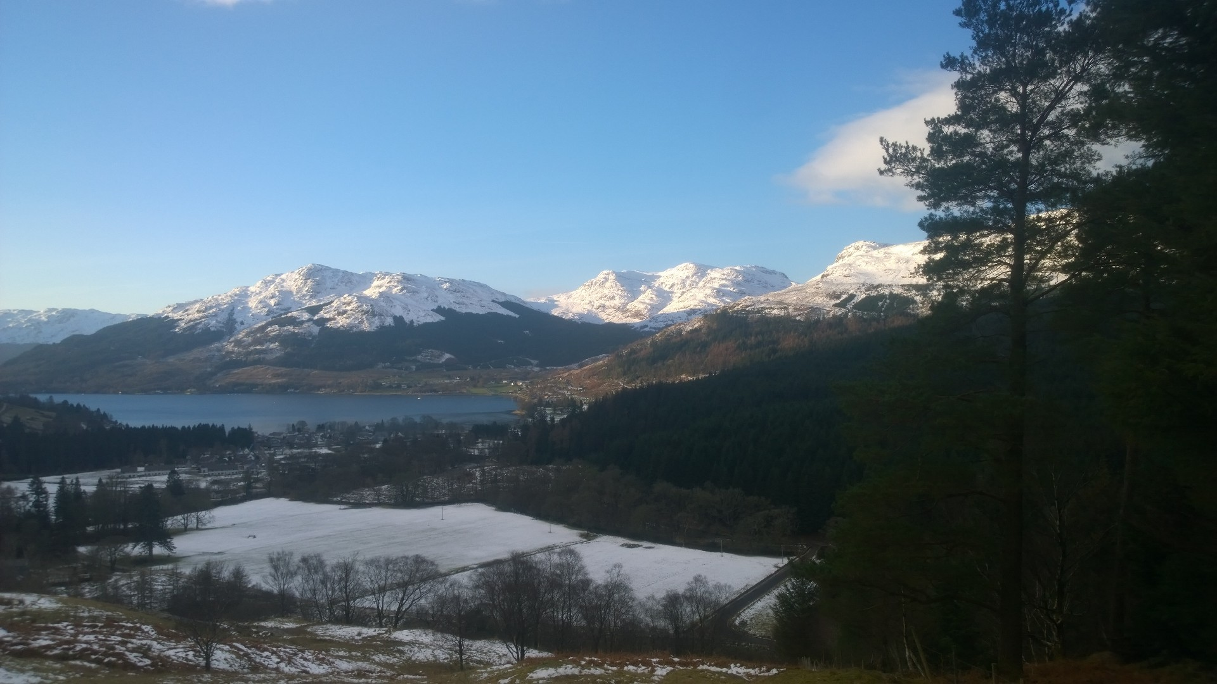
January 2016
Fr | Sa | Su | Mo | Tu | We | Th | Fr | Sa | Su | Mo | Tu | We | Th | Fr | Sa | Su | Mo | Tu | We | Th | Fr | Sa | Su | Mo | Tu | We | Th | Fr | Sa | Su
1 | 2 | 3 | 4 | 5 | 6 | 7 | 8 | 9 | 10 | 11 | 12 | 13 | 14 | 15 | 16 | 17 | 18 | 19 | 20 | 21 | 22 | 23 | 24 | 25 | 26 | 27 | 28 | 29 | 30 | 31
 |  |  |  |  | 1st: New Year’s Day
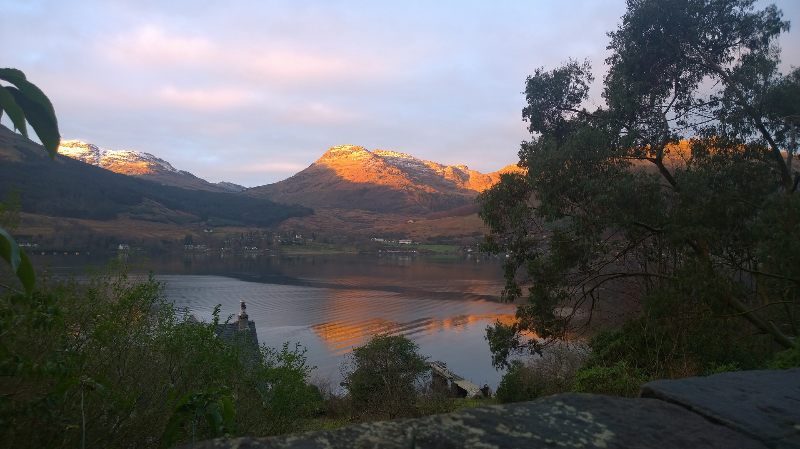
February 2016
Mo | Tu | We | Th | Fr | Sa | Su | Mo | Tu | We | Th | Fr | Sa | Su | Mo | Tu | We | Th | Fr | Sa | Su | Mo | Tu | We | Th | Fr | Sa | Su | Mo
1 | 2 | 3 | 4 | 5 | 6 | 7 | 8 | 9 | 10 | 11 | 12 | 13 | 14 | 15 | 16 | 17 | 18 | 19 | 20 | 21 | 22 | 23 | 24 | 25 | 26 | 27 | 28 | 29

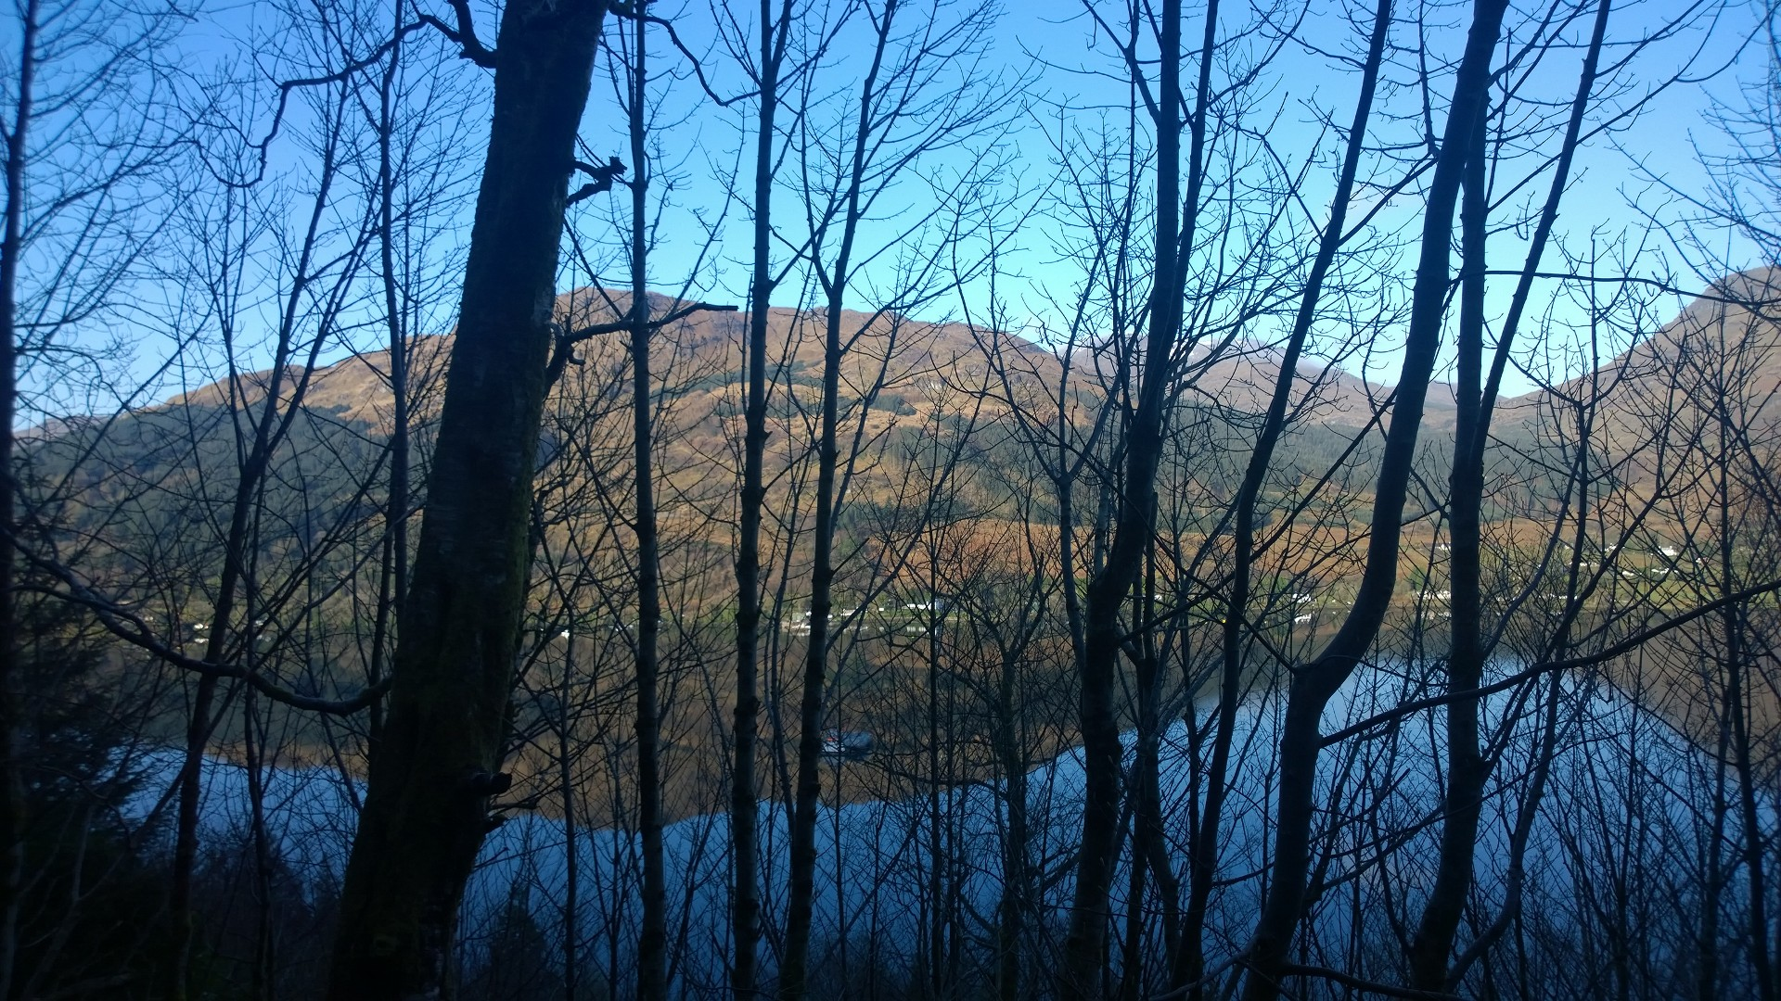
March 2016
Tu | We | Th | Fr | Sa | Su | Mo | Tu | We | Th | Fr | Sa | Su | Mo | Tu | We | Th | Fr | Sa | Su | Mo | Tu | We | Th | Fr | Sa | Su | Mo | Tu | We | Th
1 | 2 | 3 | 4 | 5 | 6 | 7 | 8 | 9 | 10 | 11 | 12 | 13 | 14 | 15 | 16 | 17 | 18 | 19 | 20 | 21 | 22 | 23 | 24 | 25 | 26 | 27 | 28 | 29 | 30 | 31
 |  |  |  |  | 25th: Good Friday, 28th: Easter Monday

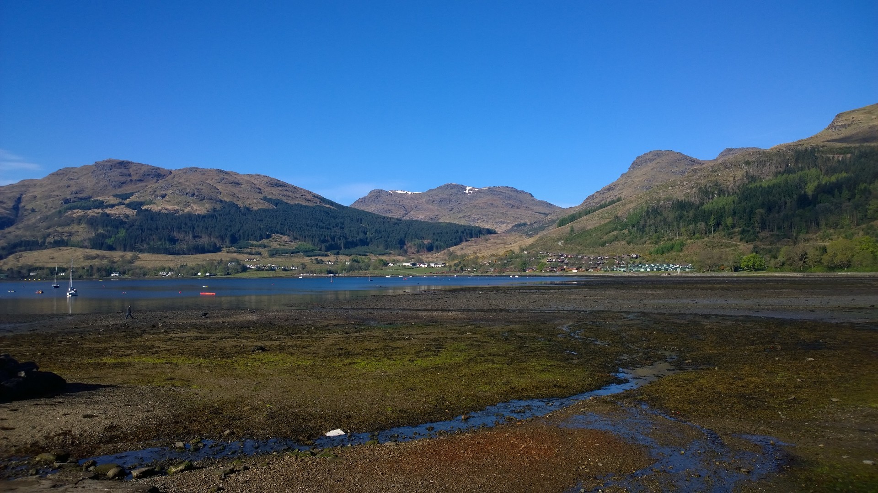
April 2016
Fr | Sa | Su | Mo | Tu | We | Th | Fr | Sa | Su | Mo | Tu | We | Th | Fr | Sa | Su | Mo | Tu | We | Th | Fr | Sa | Su | Mo | Tu | We | Th | Fr | Sa
1 | 2 | 3 | 4 | 5 | 6 | 7 | 8 | 9 | 10 | 11 | 12 | 13 | 14 | 15 | 16 | 17 | 18 | 19 | 20 | 21 | 22 | 23 | 24 | 25 | 26 | 27 | 28 | 29 | 30

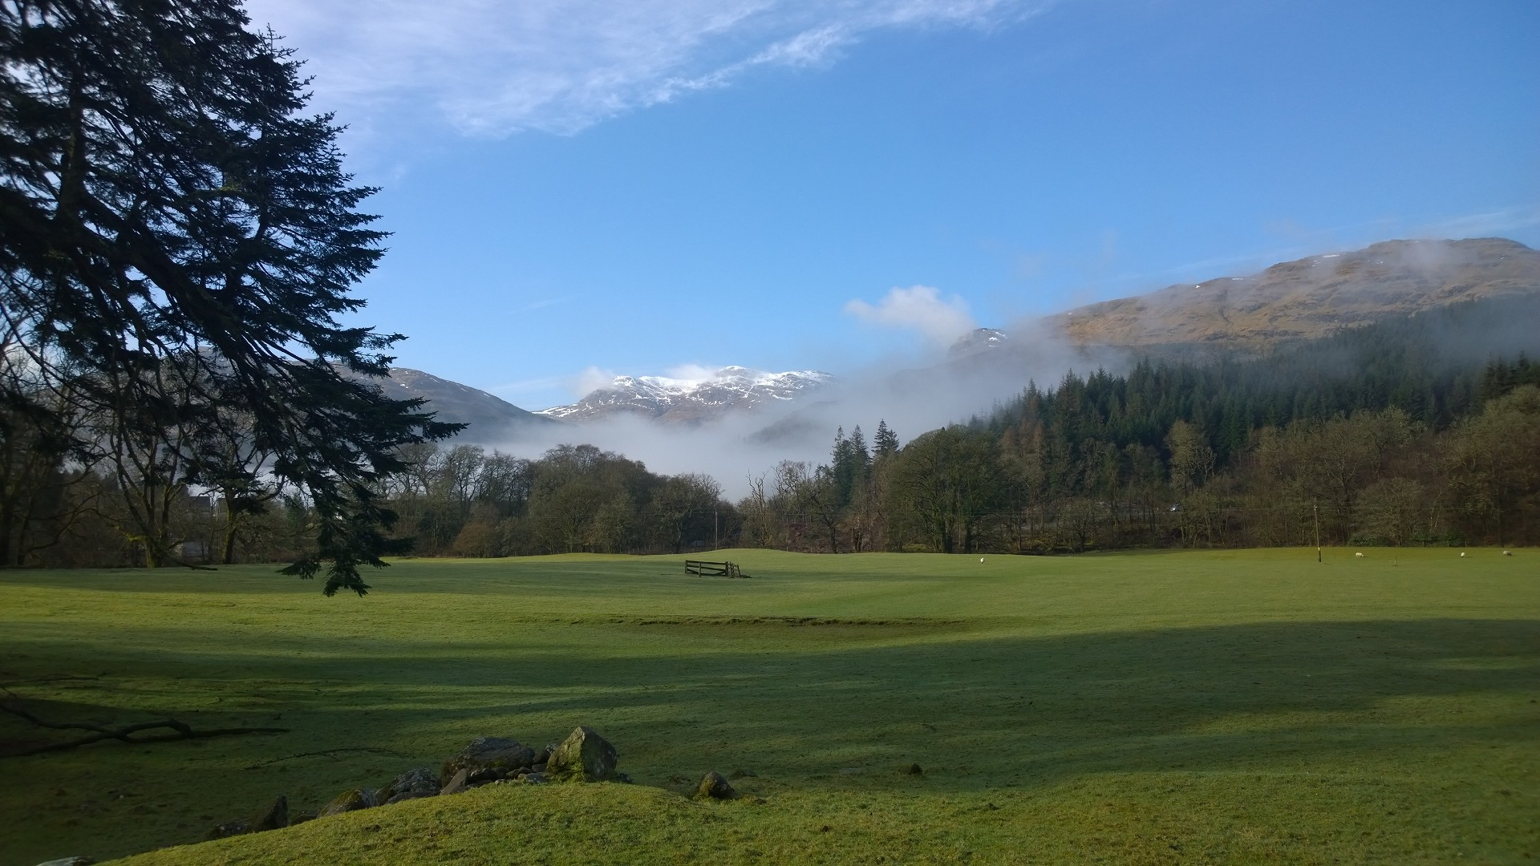
May 2016
Su | Mo | Tu | We | Th | Fr | Sa | Su | Mo | Tu | We | Th | Fr | Sa | Su | Mo | Tu | We | Th | Fr | Sa | Su | Mo | Tu | We | Th | Fr | Sa | Su | Mo | Tu
1 | 2 | 3 | 4 | 5 | 6 | 7 | 8 | 9 | 10 | 11 | 12 | 13 | 14 | 15 | 16 | 17 | 18 | 19 | 20 | 21 | 22 | 23 | 24 | 25 | 26 | 27 | 28 | 29 | 30 | 31
 |  |  |  |  | 2nd: Early May Bank Holiday (May Day), 30th: Spring Bank Holiday

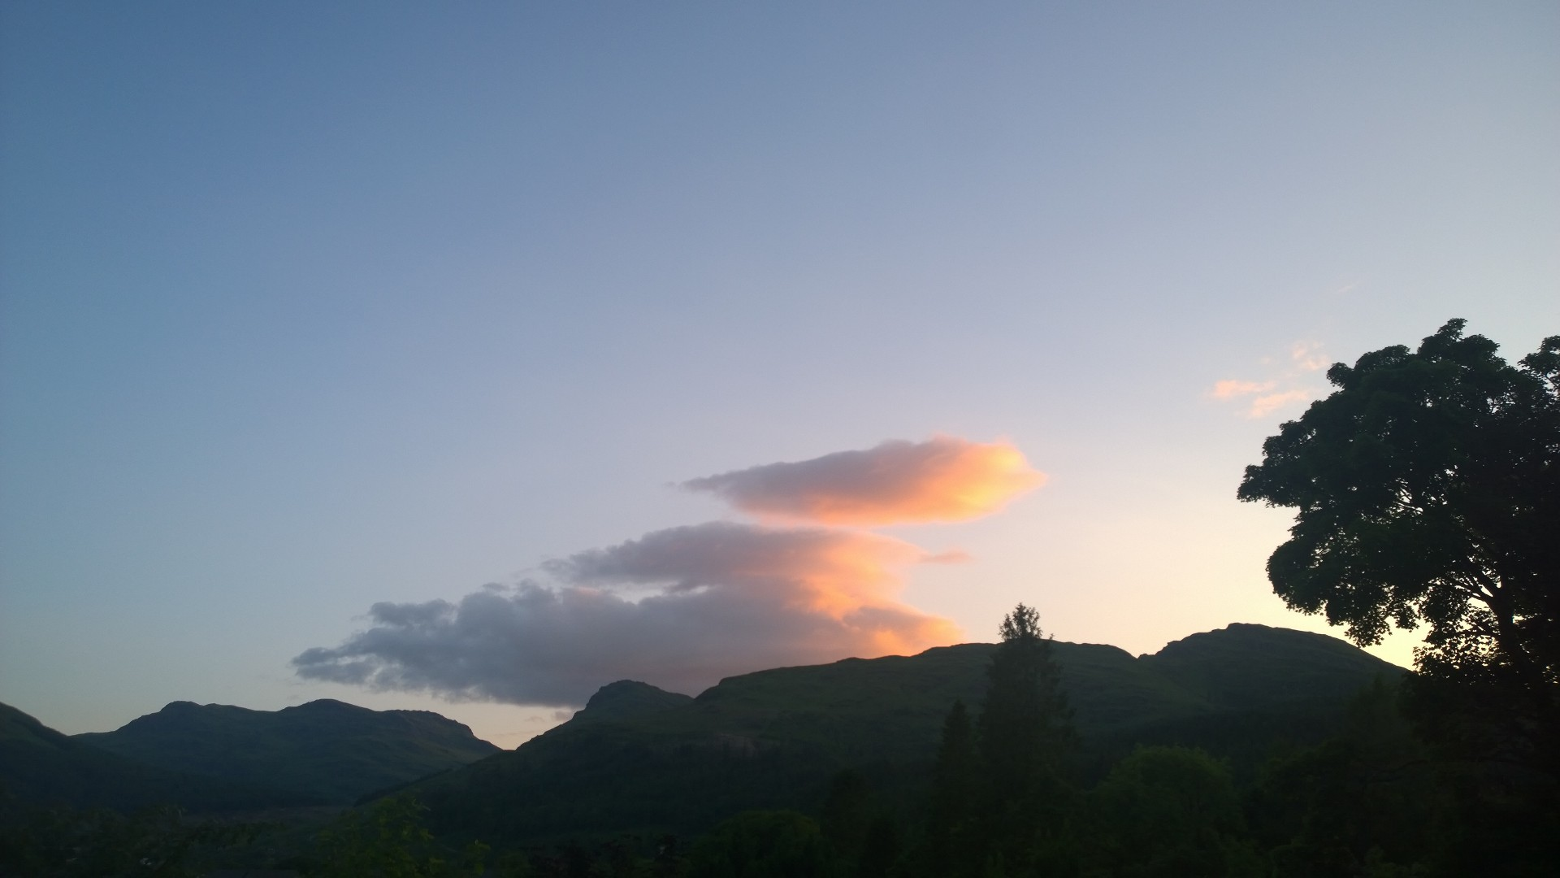
June 2016
We | Th | Fr | Sa | Su | Mo | Tu | We | Th | Fr | Sa | Su | Mo | Tu | We | Th | Fr | Sa | Su | Mo | Tu | We | Th | Fr | Sa | Su | Mo | Tu | We | Th
1 | 2 | 3 | 4 | 5 | 6 | 7 | 8 | 9 | 10 | 11 | 12 | 13 | 14 | 15 | 16 | 17 | 18 | 19 | 20 | 21 | 22 | 23 | 24 | 25 | 26 | 27 | 28 | 29 | 30

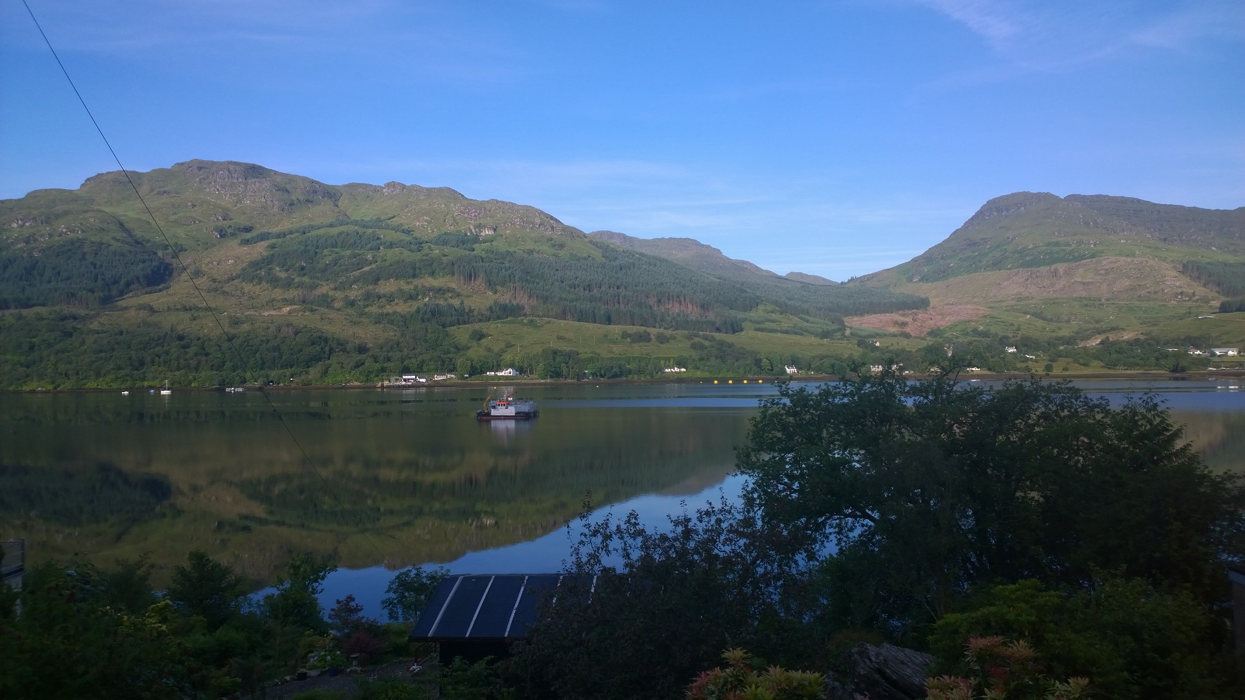
July 2016
Fr | Sa | Su | Mo | Tu | We | Th | Fr | Sa | Su | Mo | Tu | We | Th | Fr | Sa | Su | Mo | Tu | We | Th | Fr | Sa | Su | Mo | Tu | We | Th | Fr | Sa | Su
1 | 2 | 3 | 4 | 5 | 6 | 7 | 8 | 9 | 10 | 11 | 12 | 13 | 14 | 15 | 16 | 17 | 18 | 19 | 20 | 21 | 22 | 23 | 24 | 25 | 26 | 27 | 28 | 29 | 30 | 31

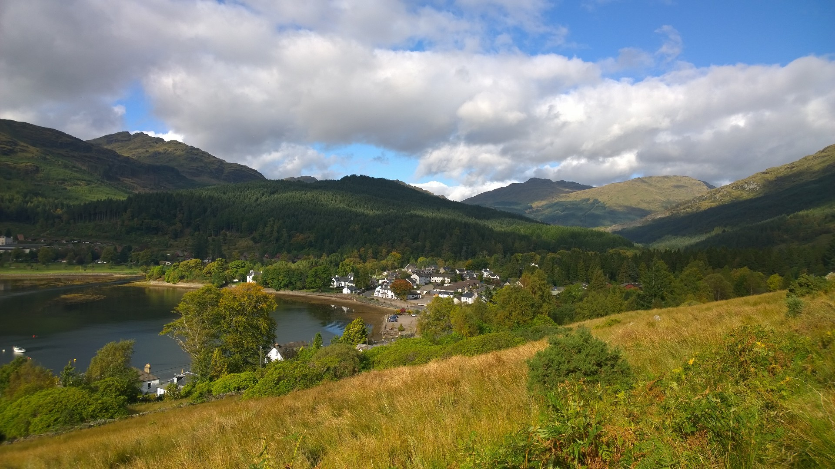
August 2016
Mo | Tu | We | Th | Fr | Sa | Su | Mo | Tu | We | Th | Fr | Sa | Su | Mo | Tu | We | Th | Fr | Sa | Su | Mo | Tu | We | Th | Fr | Sa | Su | Mo | Tu | We
1 | 2 | 3 | 4 | 5 | 6 | 7 | 8 | 9 | 10 | 11 | 12 | 13 | 14 | 15 | 16 | 17 | 18 | 19 | 20 | 21 | 22 | 23 | 24 | 25 | 26 | 27 | 28 | 29 | 30 | 31
 |  |  |  |  | 29th: August Bank Holiday

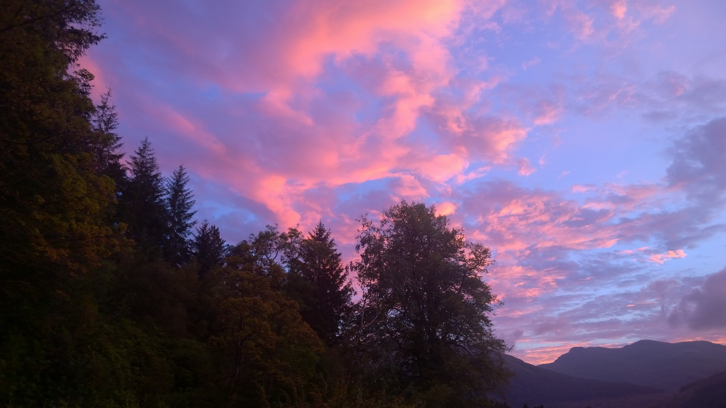
September 2016
Th | Fr | Sa | Su | Mo | Tu | We | Th | Fr | Sa | Su | Mo | Tu | We | Th | Fr | Sa | Su | Mo | Tu | We | Th | Fr | Sa | Su | Mo | Tu | We | Th | Fr
1 | 2 | 3 | 4 | 5 | 6 | 7 | 8 | 9 | 10 | 11 | 12 | 13 | 14 | 15 | 16 | 17 | 18 | 19 | 20 | 21 | 22 | 23 | 24 | 25 | 26 | 27 | 28 | 29 | 30

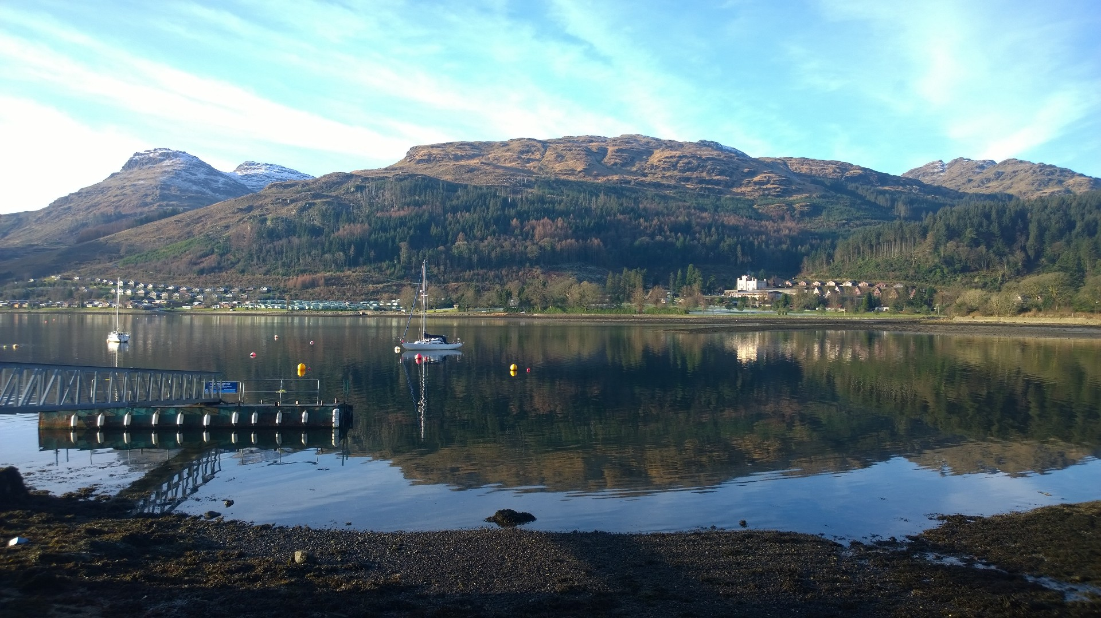
October 2016
Sa | Su | Mo | Tu | We | Th | Fr | Sa | Su | Mo | Tu | We | Th | Fr | Sa | Su | Mo | Tu | We | Th | Fr | Sa | Su | Mo | Tu | We | Th | Fr | Sa | Su | Mo
1 | 2 | 3 | 4 | 5 | 6 | 7 | 8 | 9 | 10 | 11 | 12 | 13 | 14 | 15 | 16 | 17 | 18 | 19 | 20 | 21 | 22 | 23 | 24 | 25 | 26 | 27 | 28 | 29 | 30 | 31

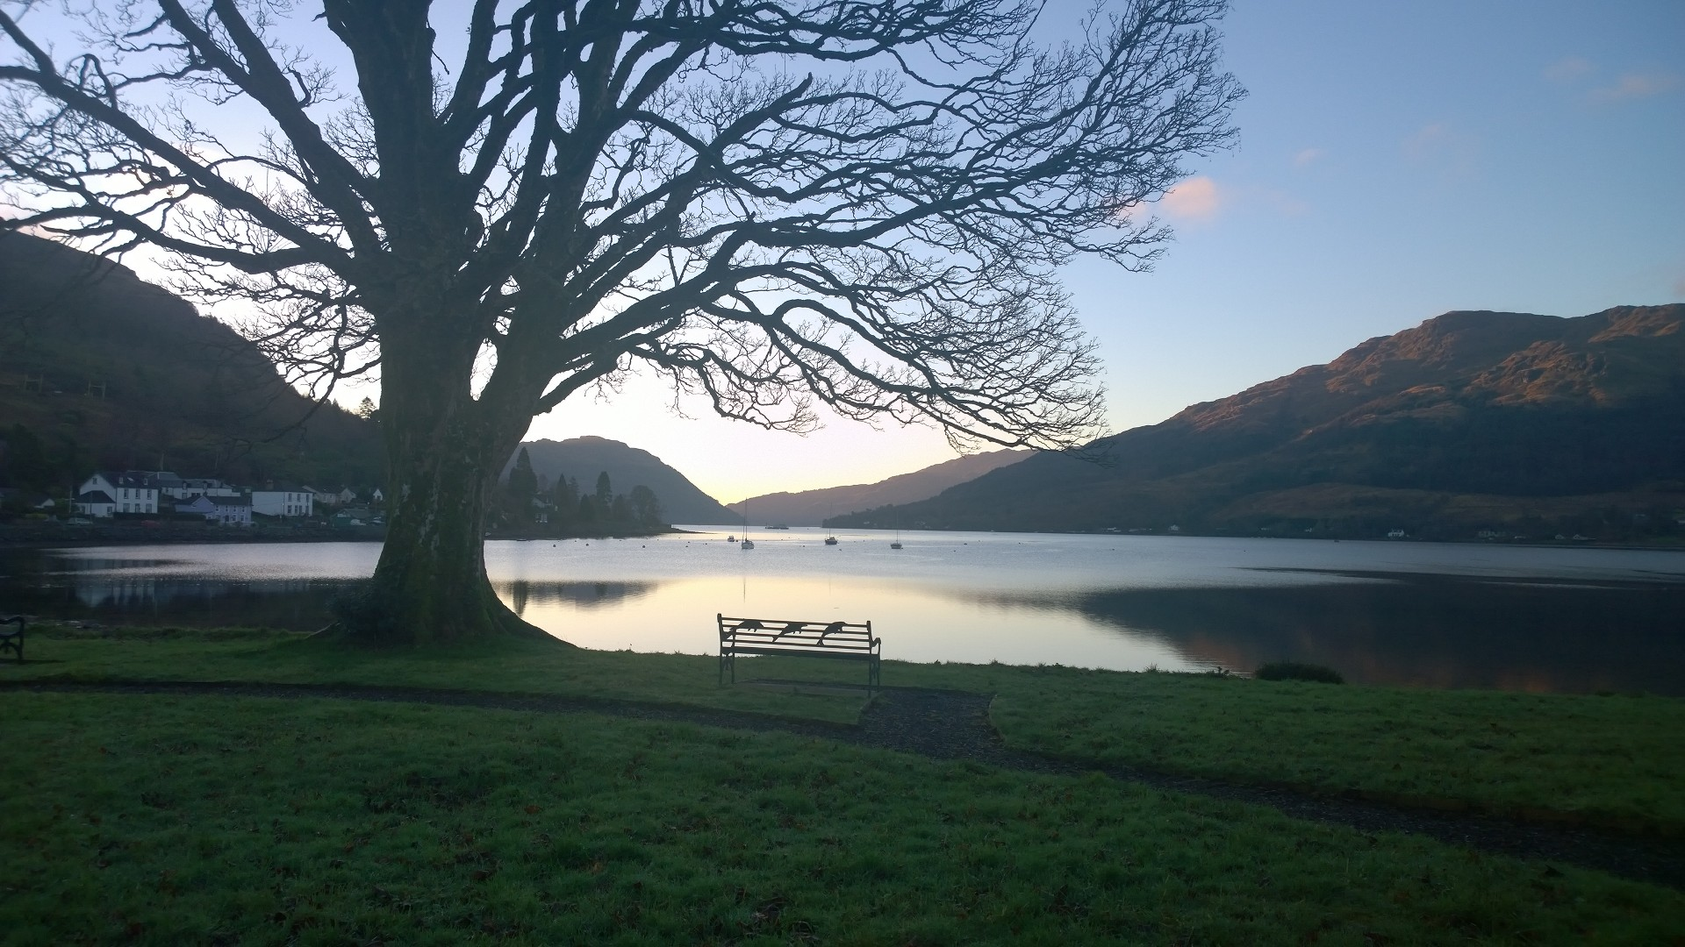
November 2016
Tu | We | Th | Fr | Sa | Su | Mo | Tu | We | Th | Fr | Sa | Su | Mo | Tu | We | Th | Fr | Sa | Su | Mo | Tu | We | Th | Fr | Sa | Su | Mo | Tu | We
1 | 2 | 3 | 4 | 5 | 6 | 7 | 8 | 9 | 10 | 11 | 12 | 13 | 14 | 15 | 16 | 17 | 18 | 19 | 20 | 21 | 22 | 23 | 24 | 25 | 26 | 27 | 28 | 29 | 30

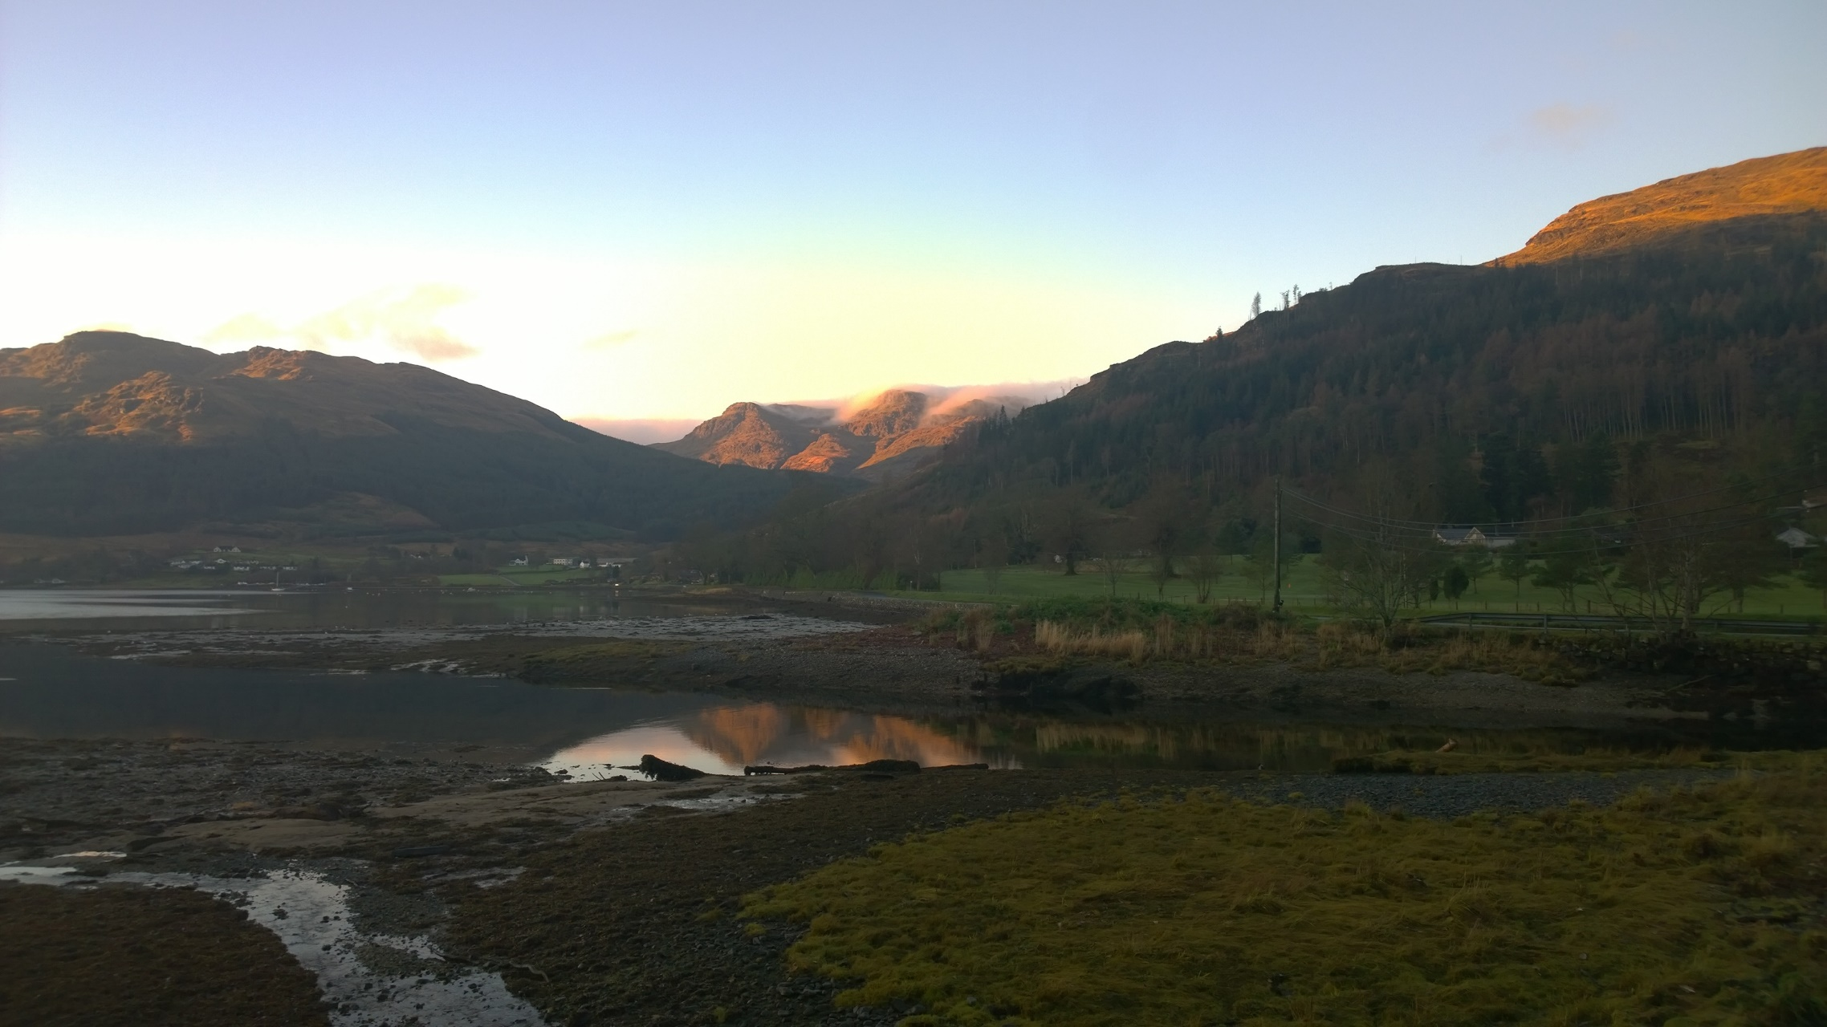
December 2016
Th | Fr | Sa | Su | Mo | Tu | We | Th | Fr | Sa | Su | Mo | Tu | We | Th | Fr | Sa | Su | Mo | Tu | We | Th | Fr | Sa | Su | Mo | Tu | We | Th | Fr | Sa
1 | 2 | 3 | 4 | 5 | 6 | 7 | 8 | 9 | 10 | 11 | 12 | 13 | 14 | 15 | 16 | 17 | 18 | 19 | 20 | 21 | 22 | 23 | 24 | 25 | 26 | 27 | 28 | 29 | 30 | 31
 |  |  |  |  | 25th: Christmas Day, 26th: Boxing Day, 27th: Bank holiday substitute day (for Christmas Day)

